UI Design Using RAD Model – Food Delivery App

# Aim:

To demonstrate the lifecycle stages of UI design using the RAD (Rapid Application Development) model, and showcase a working prototype of a Food Delivery App

# RAD Model Phases in My Project

## 1. Requirements Planning Phase:

In this phase, I gathered the initial requirements for a food delivery application by considering the user needs and typical app functionalities.

* Key Features Identified:
* User login/signup
* Viewing food categories and items
* Product details with images and prices
* Add to cart and order management
* Checkout process
* User Stories:
* As a user, I want to browse food items so I can select what to order.
* As a user, I want to add items to my cart and view the total cost.
* As a user, I want a smooth checkout process to confirm my order.

## 2. User Design Phase:

I created wireframes and interactive mockups to visualize the design.

* Screens Designed:
* Login Page – To authenticate users.
* Home Page – Showcases featured items or categories.
* Menu/Listings Page – Displays available food items.
* Product Details Page – Shows selected item info, image, and price.
* Cart Page – Lists items added with total and checkout option.
* Interactions Added:
* Navigation between pages (e.g., button click leads to cart or product details).
* Visual transitions and element groupings for smooth UX.
* User Feedback:
* I shared the prototype with peers and received suggestions like improving button visibility and adjusting layout spacing, which I implemented.

## 3. Construction Phase:

Here, I transformed my wireframes into a functional prototype using interactive features.

* Buttons were linked for navigation.
* Component styles were reused across screens for consistency.
* I included auto-layouts and frames to maintain responsive design structure.

## 4. Cutover Phase:

This phase involved final review and sharing the prototype:

* I finalized the UI by reviewing interactions and layout alignment.
* The prototype was shared via Figma link for user testing and feedback.
* Based on inputs, I updated colors, spacing, and text for better readability.

# Screenshots of Design

Below is a screenshot from the Figma design that represents the Welcome Screen of the Food Delivery App. This screen is part of the 'User Design Phase' and showcases the visual entry point for users.

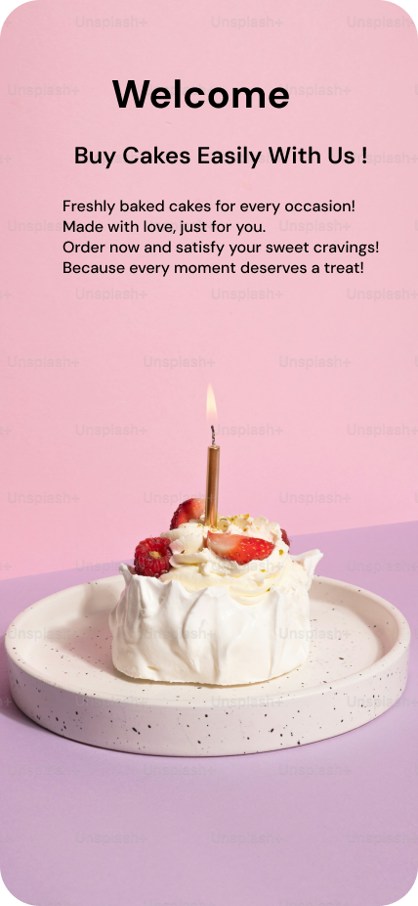

The following screen showcases the Home Page or Product Browsing interface. This screen allows users to explore various cake categories and products with pricing, making it an essential part of the user experience.

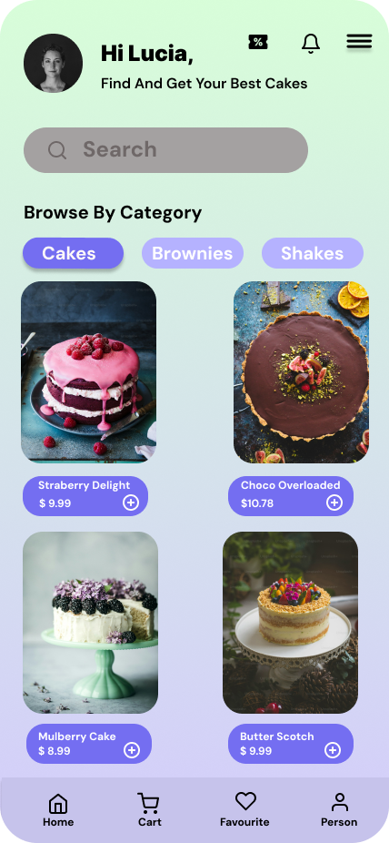

cakes Category – Product list under selected category.

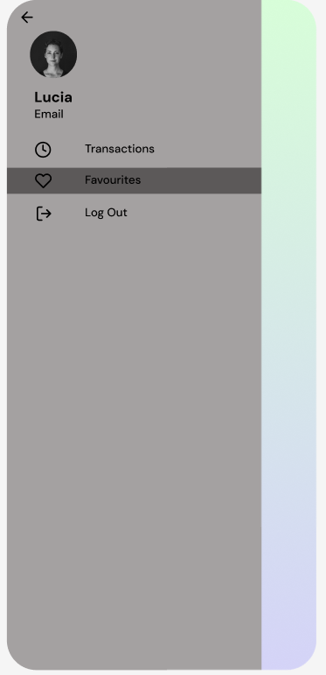

User Profile / Sidebar Menu – Account options like transactions and logout

# Conclusion:

Using the RAD model, I was able to design a responsive and user-friendly interface for a Food Delivery App efficiently. Tools like Figma allowed me to iterate quickly, gather feedback, and simulate real-user flows without actual code.